Unearthing the Environmental Impact of Human Activity

- A Global CO2 Emission Analysis

# Business problem:

Global warming is one of the biggest challenges currently being faced by the human race, although correlation is not causation, a likely cause of global warming is due to increased atmospheric carbon dioxide from human activities. CO2 Emission refers to the Carbon Dioxide emitted throughout the world. For this analysis we will be focusing on CO2 Emissions and its effect on the world we live in as well as some key factors and stats that may play a role in the emission of CO2 globally. Fossil fuel use is the primary source of CO2. The data throws light onto how much fossil fuels are burnt, per year per nation, which amounts to an increase in CO2 every year. This will help researchers and environment experts to predict global warming. So countries should set a goal to decrease this amount yearly. Analysing Global Co2 Emission across countries from 1975 to 2020. This dataset contains a record of Co2 Emission by each Country and Region of Earth, here we are going to analyse and visualise Country wise, Region wise and Overall Co2 Emission on Earth.

# Business requirements:

The business requirements for analysing the Co2 Emission Globally over time, identifying affecting factors, creating interactive dashboards and reports, identifying areas for improvement, making data-driven decisions, comparing to countries average and creating forecasting models for future performance. The ultimate goal is to gain insights and reduce the emission through data visualization techniques.

# Social or Business Impact:

Social Impact: Carbon dioxide emissions are the primary driver of global climate change. It’s widely recognised that to avoid the worst impacts of climate change, the world needs to urgently reduce emissions. Business Model/Impact: By conducting an analysis the countries can identify areas for improvement and take steps to reduce factors that are responsible for Co2 Emission for environmental sustainability by improving the efficiency and transitioning to low carbon alternatives.

# Data Collection:

Data collection is the process of gathering and measuring information on variables of interest, in an established systematic fashion that enables one to answer stated research questions, test hypotheses, and evaluate outcomes and generate insights from the data.

# Understanding the data:

Dataset consists of CO2 emissions in metric ton per capita of every country around the world. The data is collected from 1975 to 2020. In this dataset Countries and regions are included. Data is initially pre-processed using excel. The dataset contains

* Country- Country for which Co2 is Recorded
* Year- Year the data was recorded
* Co2 Emission (In Million Metric Tons )
* Co2 Growth per Capita
* Co2 Per Capita
* Cumulative Co2
* Several Fossil Fuels rate of Emission

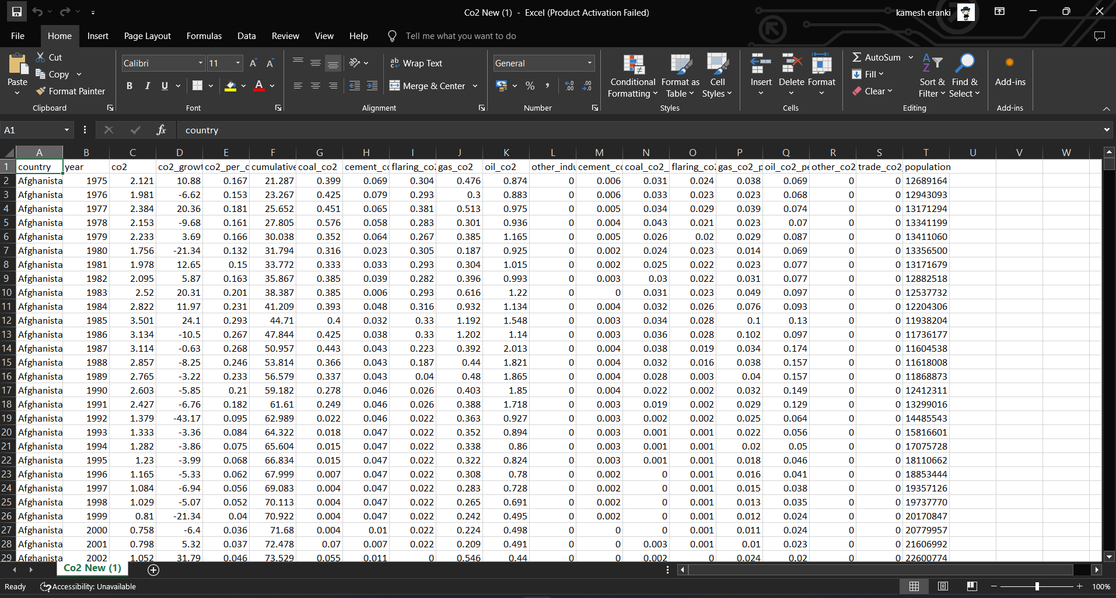

# Data Preparation:

Preparing the data for visualization involves cleaning the data to remove irrelevant or missing data, transforming the data into a format that can be easily visualized, exploring the data to identify patterns and trends, filtering the data to focus on specific subsets of data, preparing the data for visualization software, and ensuring the data is accurate and complete. Since the Data is initially pre- processed we can skip this step. Basically this process helps to make the data easily understandable and ready for creating visualizations to gain insights into the performance and efficiency.

# Data Visualization:

Data visualization is the process of creating graphical representations of data in order to help people understand and explore the information. The goal of data visualization is to make complex data sets more accessible, intuitive, and easier to interpret. By using visual elements such as charts, graphs, and maps, data visualizations can help people quickly identify patterns, trends, and outliers in the data.

# Screenshot (1)Screenshot (2)

# Screenshot (6)

# Dashboard:

A dashboard is a graphical user interface (GUI) that displays information and data in an organized, easy-to-read format. Dashboards are often used to provide real- time monitoring and analysis of data, and are typically designed for a specific purpose or use case. Dashboards can be used in a variety of settings, such as business, finance, manufacturing, healthcare, and many other industries. They can be used to track key performance indicators (KPIs), monitor performance metrics, and display data in the form of charts, graphs, and tables.

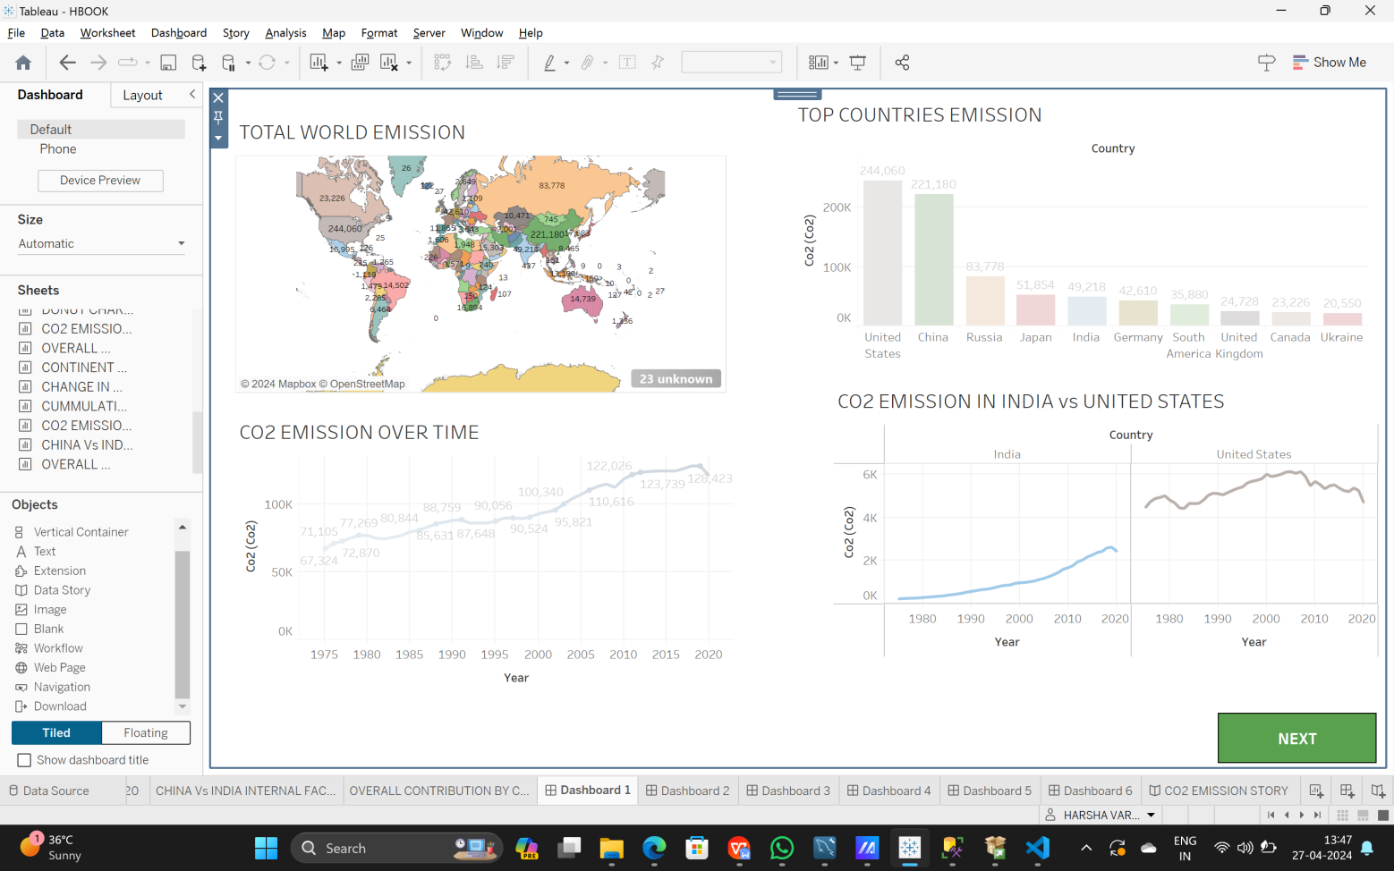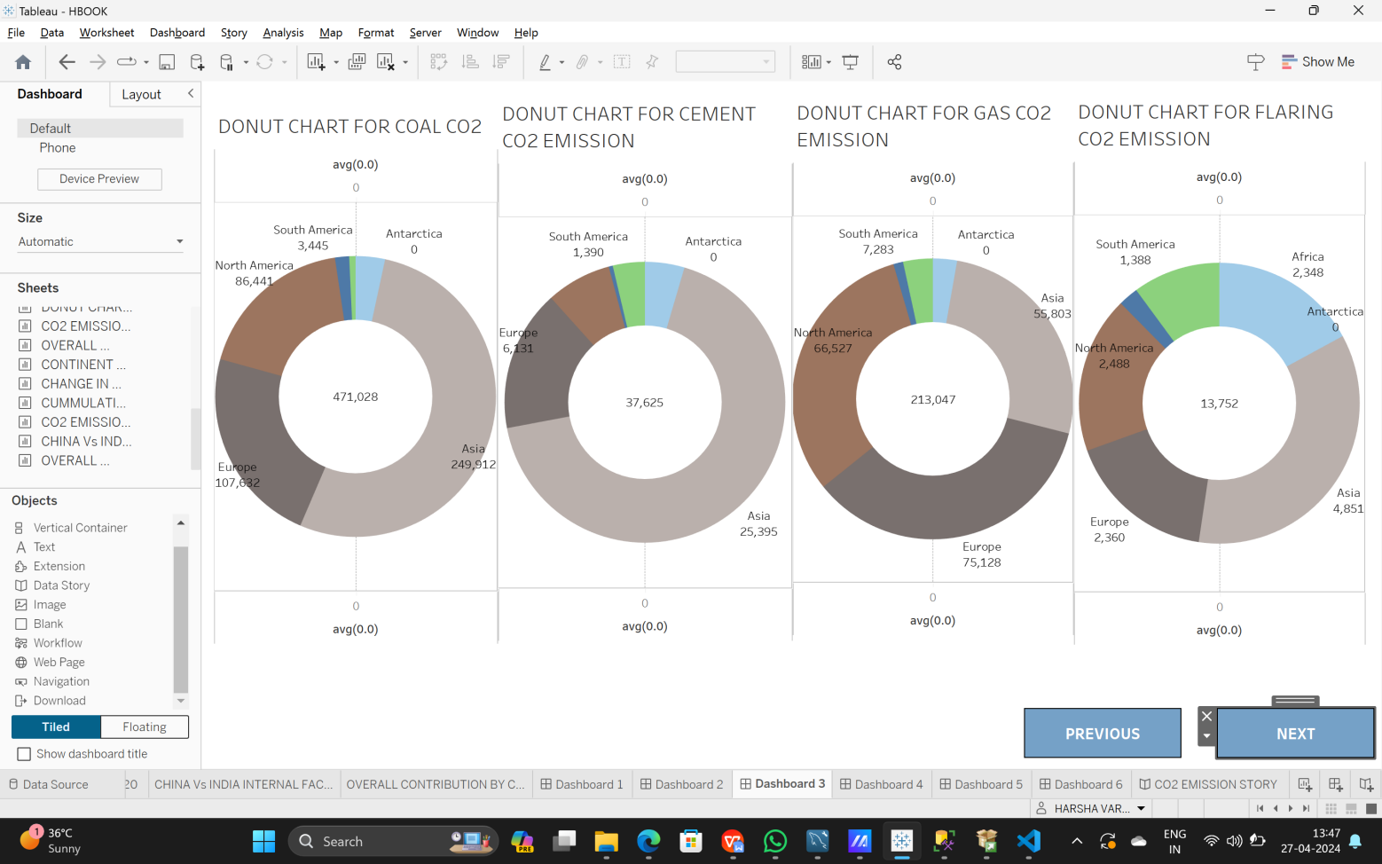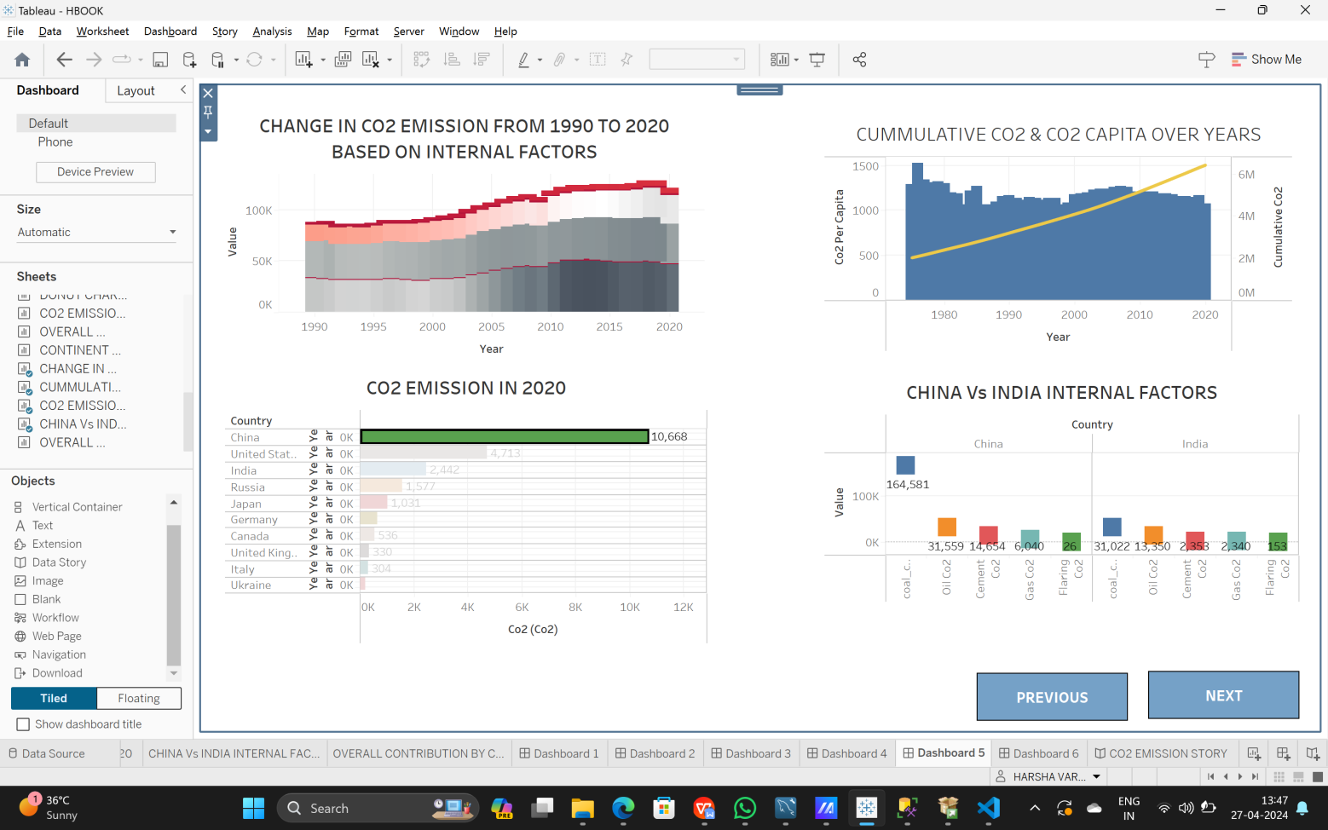

# Story:

A data story is a way of presenting data and analysis in a narrative format, with the goal of making the information more engaging and easier to understand. A data story typically includes a clear introduction that sets the stage and explains the context for the data, a body that presents the data and analysis in a logical and systematic way, and a conclusion that summarizes the key findings and highlights their implications. Data stories can be told using a variety of mediums, such as reports, presentations, interactive visualizations, and videos.

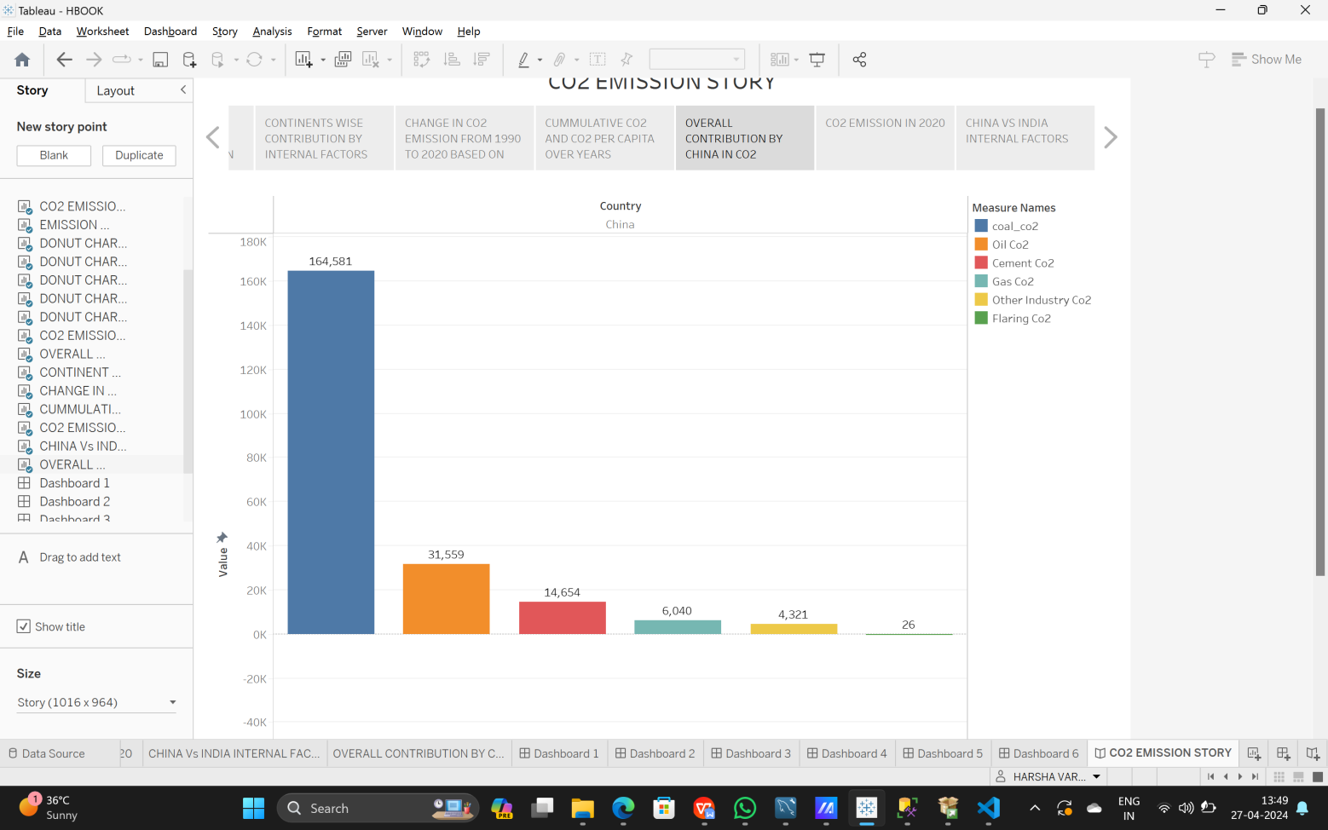

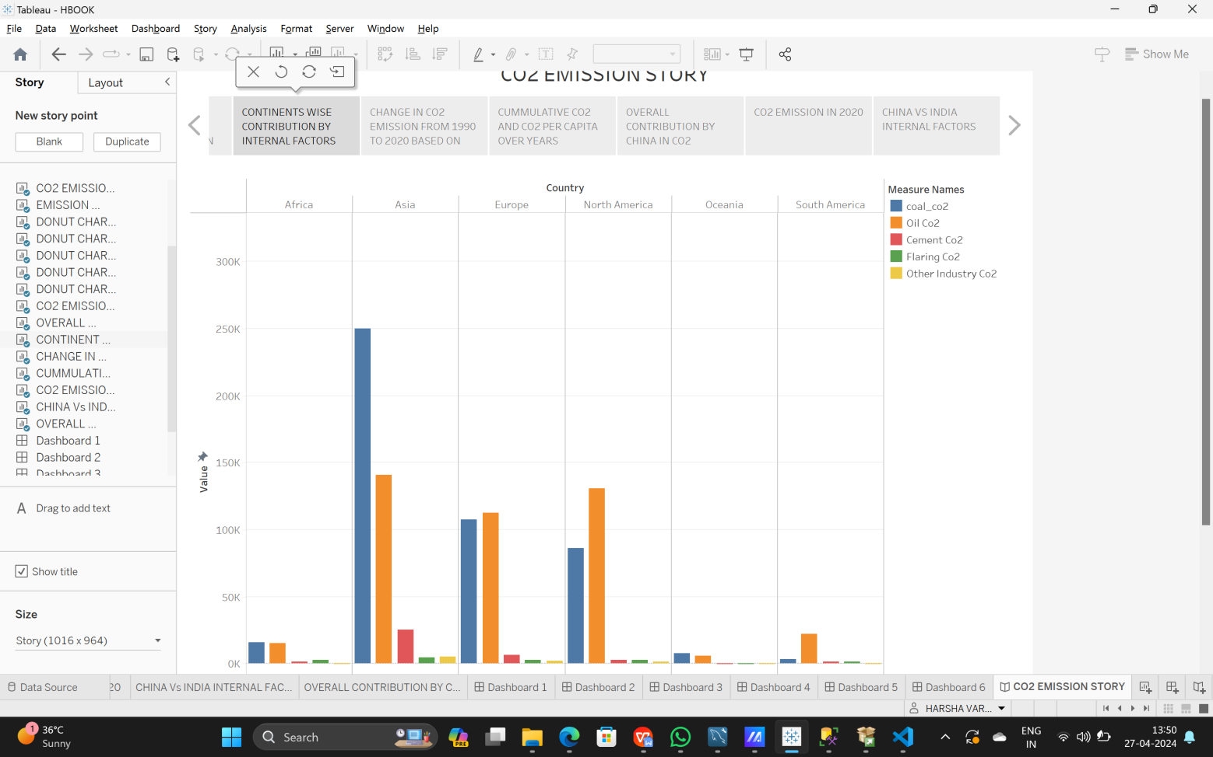

## Web integration:

Publishing helps us to track and monitor key performance metrics, to communicate results and progress. help a publisher stay informed, make better decisions, and communicate their performance to others.

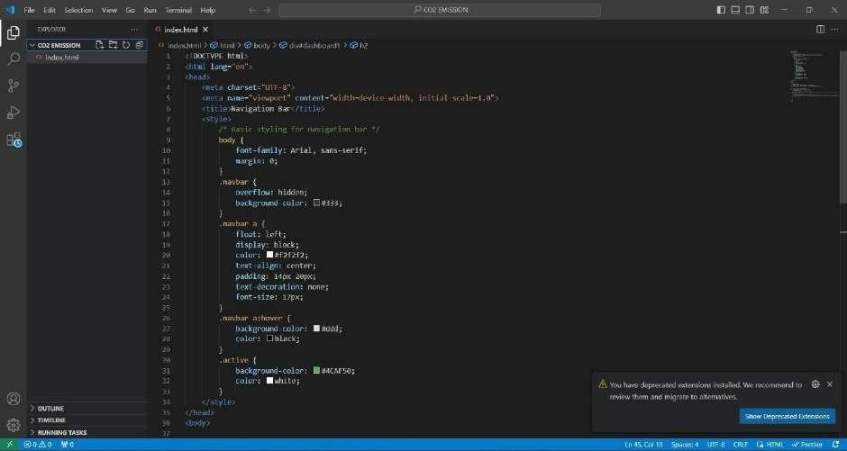

Publishing the book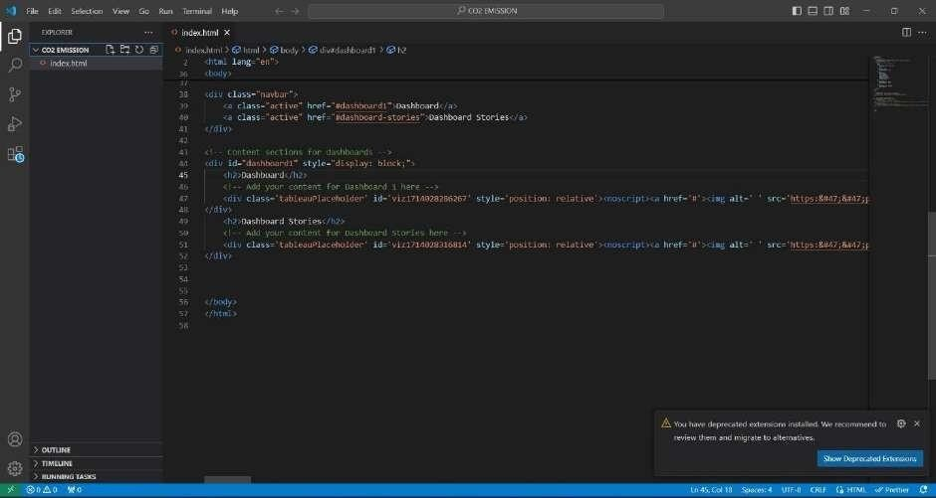:

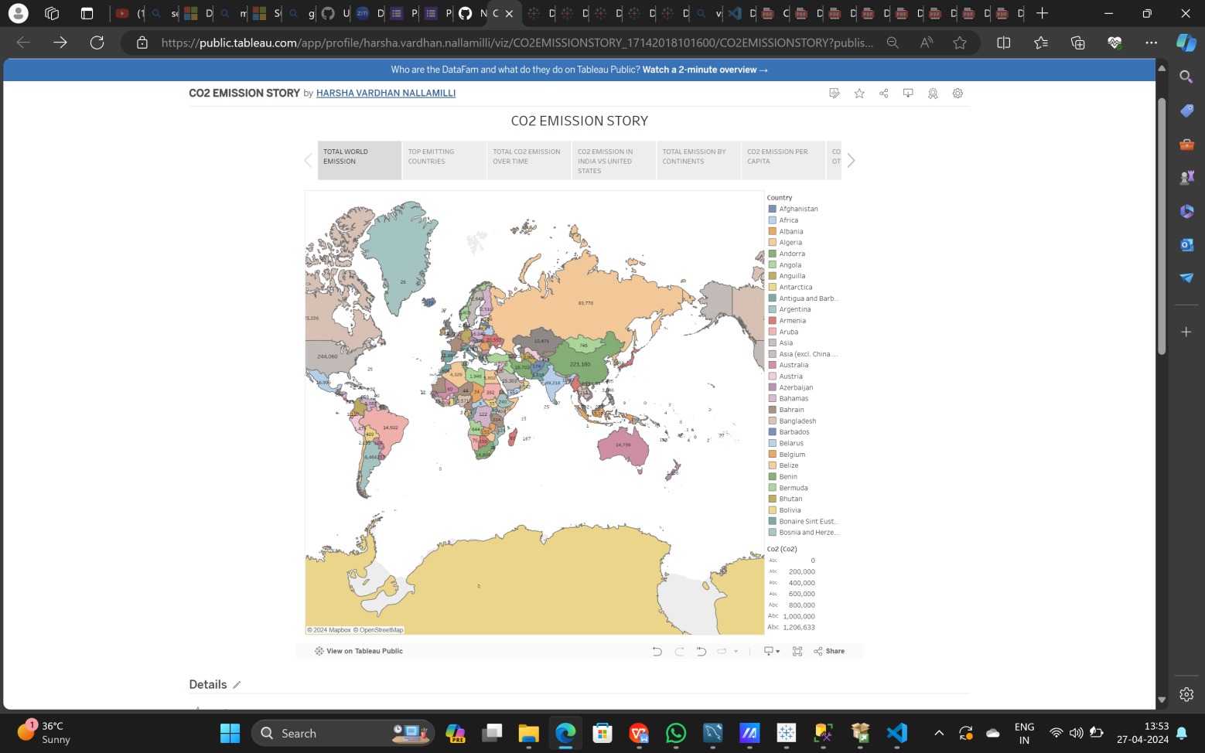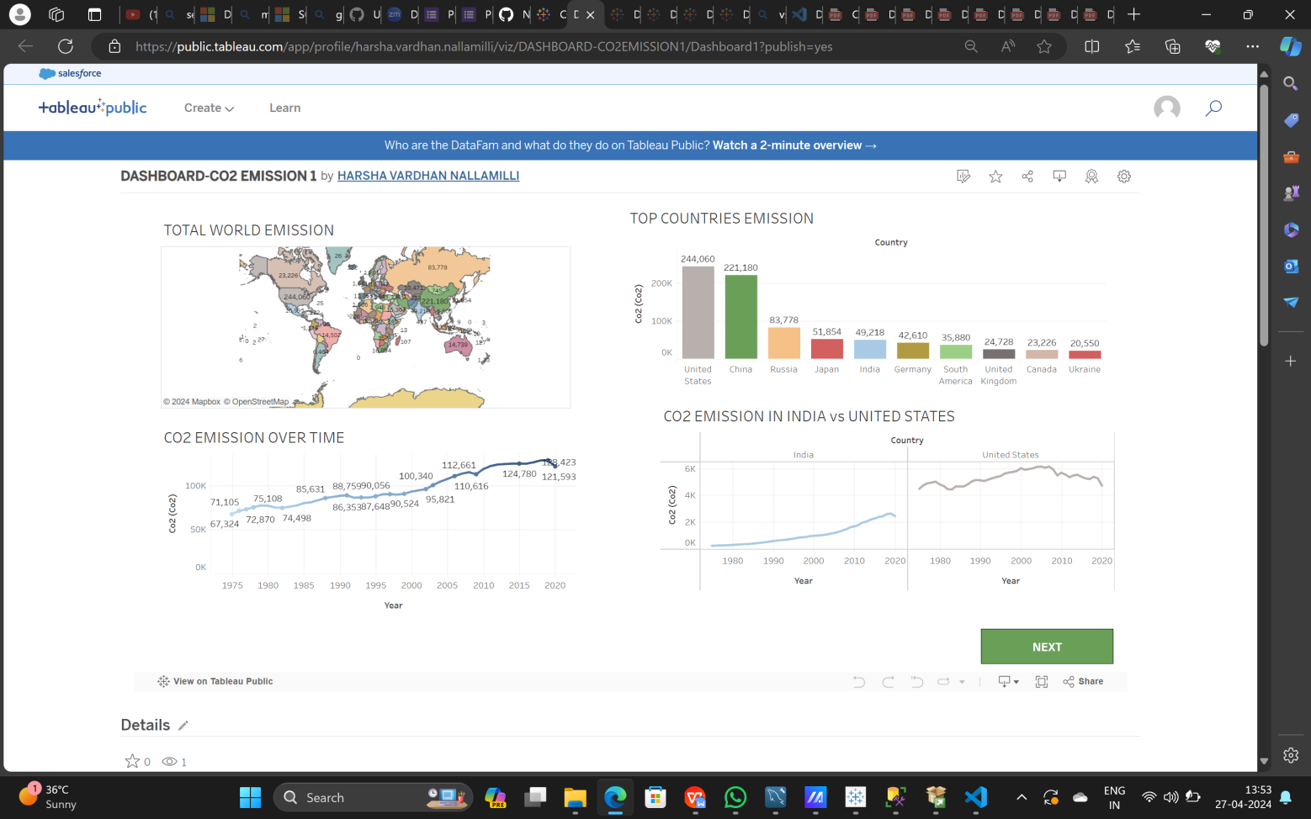

## BY:

**Nallamilli Harsha Vardhan**

**20A31A0138**

## Pragati Engineering College